Theoretical Exam - Short Questions
- At Brazil’s National Observatory, located at the city of Rio de Janeiro (22° 54’ S, 43° 12’ W), there is a sundial above the door of the dome of the 32cm telescope, facing to the north. The dial lies on the plane East-Zenith-West and the rod is parallel to the Earth’s axis. For which declinations of the sun and during what period of the year (months and seasons) the clock (i) does not work during, at least, some fraction of the day?, and (ii) does not work at all during the day?

- Calculate the length of the sidereal day on Earth. What would be the length of the solar and sidereal days, in the current time measures (our solar hours, minutes and seconds), if the Earth would rotate in the opposite direction, but with the same rotation speed?

- What is the time interval between two consecutive oppositions of Mars? Assume the orbit is circular.

- What would be full Moon’s visual magnitude if its albedo were equal to 1?

- Calculate the ratio between the average densities of the Earth and the Sun, using ONLY the dataset below:
- the angular diameter of the Sun, as seen from Earth
- the gravitational acceleration on Earth’s surface
- the length of the year
- the fact that one degree in latitude at Earth’s surface corresponds to 111 km

- Most of the energy emitted by the Sun is generated in its core via the so-called proton-proton (p-p) nuclear chain reaction, which has three different branches. The most energetic branch transforms 2 He³ into He⁴ + 2H¹. Calculate the energy released (in MeV) and the fractional reduction of the mass of the particles involved in this reaction.
- Luminous Blue Variable (LBV) stars greatly vary in visual brightness; however, the bolometric magnitude remains constant. Imagine a LBV star with a black body temperature of 5 000 K at its maximum visual brightness, and 30 000 K at its minimum visual brightness. Calculate the ratio of the star radius between both situations above.

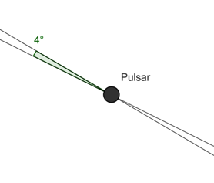
- A pulsar located 1000 pc far from Earth, 10 000 times more luminous than our Sun, emits radiation only from its two opposite poles, creating an homogeneous emission beam shaped as double cone with opening angle α = 4°. Assuming the angle between the rotation axis and the emission axis is 30°, and assuming a random orientation of the pulsar beams in relation to an observer on Earth, what is the probability of detecting the pulses? In case we can see it, what is the apparent bolometric magnitude of the pulsar?

- An old planetary nebula, with a white dwarf (WD) in its center, is located 50 pc away from Earth. Exactly in the same direction, but behind the nebula, lies another WD, identical to the first, but located at 150 pc from the Earth. Consider that the two WDs have absolute bolometric magnitude +14.2 and intrinsic color indexes B-V = 0.300 and U-V = 0.330. Extinction occurs in the interstellar medium and in the planetary nebula.
When we measure the color indices for the closer WD (the one who lies at the center of the nebula), we find the values B-V = 0.327 and U-B = 0.038. In this part of the Galaxy, the interstellar extinction rates are 1.50, 1.23 and 1.00 magnitudes per kiloparsec for the filters U, B and V, respectively. Calculate the color indices as they would be measured for the second star.

- Assume that the universe currently is well described by a density parameter Ω₀ = 1, there is no dark energy, and the current temperature of the universe is 2.73 K. Knowing that the temperature of the universe is inversely proportional to its radius (the scale factor), compute how long, starting from the present time, it will take to the Universe to cool down by 0.1 K

- What is the angular amplitude of the oscillatory motion of the Sun, due to the existence of Jupiter, as measured by an observer located at Barnard’s Star? What is the period of this oscillation?

- What is the minimum diameter of a telescope, observing in the visible and near ultraviolet bands, located in one of the Lagrangian points L4 or L5 of the Sun-Earth system, in order to be able to detect the Earth’s wobbling relative to the ecliptic plane caused by the gravitational action of the Moon?

- An astronomer in the southern hemisphere contemplates the rise of the south ecliptic pole and wonders how fun it would be if the sky started spinning around the ecliptic pole, instead of the usual celestial pole. Sketch the displacement of this observer over the Earth’s surface, to observe the stars revolving around south ecliptic pole in the same direction and with the same period that they usually revolve around the south celestial pole. Sketch the observer’s trajectory for one entire day. Determine its velocity (direction and speed) when crossing the Equator for the first time.

- An observer in Salonika (φ = +40.65°), Greece, quietly contemplates the starry sky when he realizes that a very bright object (α = 5h55min, δ = +7.41°, m = 0.45), when reaching its upper culmination, mysteriously detaches from the celestial sphere and continues moving at the same tangential speed, remaining in this movement for all eternity, Assume that the Earth stands still and the celestial sphere rotates. Then, determine the final alt-azimuthal coordinates of the object. How long will it take for its apparent magnitude to change to 6.00?

- Christ, the Redeemer is the most famous Brazilian monument. But there are many similar statues in other Brazilian cities and across the world. Imagine that an exact copy of the monument was built on Borradaile Island, at latitude φ = -66.55°, the first place south of the Antarctic Circle reached by man.
Assume the island is exactly on the Antarctic Circle, and define a Cartesian coordinate system (Oxy) on the horizontal plane, with the origin O being at the base of the Christ, the Ox axis in the East-West direction and the Oy axis in the North-South direction. Determine the equation of the curve described by the tip of the Christ’s head shadow on the horizontal plane, on a sunny solstice day and the minimum length of the shadow during that day (neglect the motion of the sun in declination during the day). Neglect the atmospheric effects.

Theoretical Exam - Long Questions
- An astronomer on Earth observes a globular cluster, which has an angular diameter α and contains N stars, each one with the same absolute magnitude M₀, and is at a distance D from the Earth. A biologist is in the center of that cluster.
  - What is the difference between the combined visual magnitudes of all stars observed by the astronomer and the biologist. Consider that the spatial distribution of stars in the cluster is perfectly homogeneous and the biologist is measuring the combined magnitude of the entire cluster.
  - What is the diameter of the astronomer’s telescope, considering he wants to visualize the cluster with the same brightness that the biologist sees?
  - What would be the difference between the visual magnitudes observed by the two scientists, if the diameter of the field of view of the biologist is also α.

- Astronomers studied a spiral galaxy with an inclination angle of 90º from the plane of the sky (“edge-on”) and apparent magnitude 8.5. They measured the rotational velocity and radial distance from the Galactic center and plotted its rotation curve.
  - Approximate the rotation curve in Figure 1 with a continuous function V(D) composed of two straight lines.
  - Using the same observations, they estimated that the rotation period of the pressure wave in the galactic disk is half of the rotation period of the mass of the disk. Estimate the time it takes for a spiral arm to take another turn around the galactic center (use the function constructed in 2.1).
  - Calculate the distance to the galaxy using the Tully-Fisher relation (see Table of Constants).
  - Calculate the maximum and minimum values of the observed wavelengths of the hydrogen lines corresponding to 656.28 nm in the spectrum of this galaxy. Hint: also take into account the cosmological expansion.
  - Using Figure 1, estimate the mass of the galaxy up to a radius of 3x10³ light-years.
  - Estimate the number of stars of the galaxy, assuming that:
- the mean mass of the stars is equal to one solar mass and one third of the baryonic mass of the galaxy is in the form of stars , and;
- the fraction of baryonic to dark matter in the galaxy is the same as the fraction for the whole Universe (see Table of Constants).

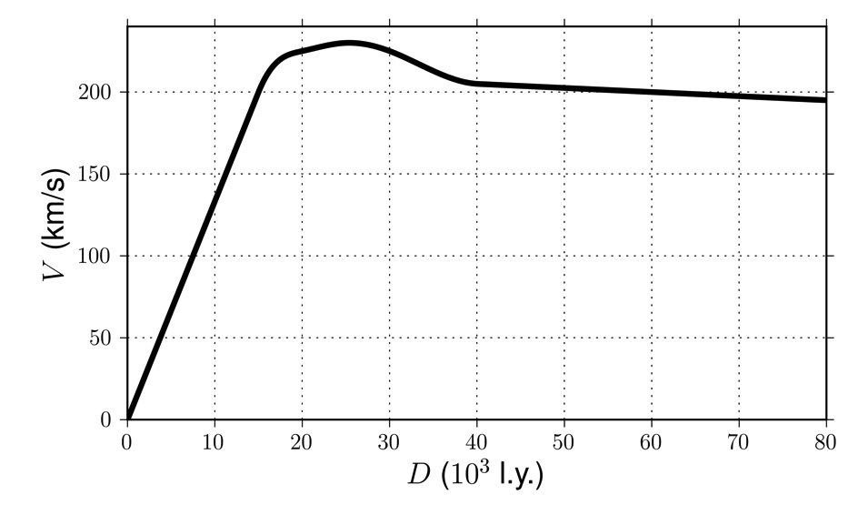
FIGURE 1

